WriteUps for Assignment 1

GDB challenges :
1.) So in this challenge a ELF executable file is provided . Now when we used gdb to get information about functions these all functions were there
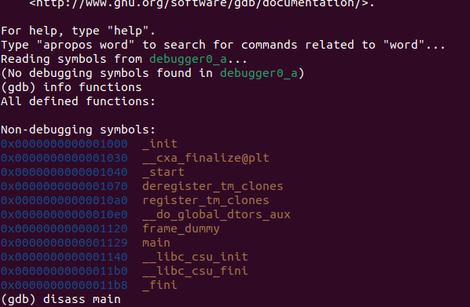

Now after disassembling the main function we get
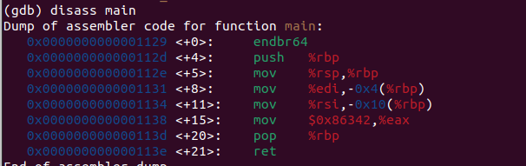
We can clearly see the the value 0x86342 is moved into eax register
the value in decimal system is 549698 which is our flag.

2.) again in this challenge a ELF executable file is provided . Now when we used gdb to get information about functions and then we disassemble the main function to get
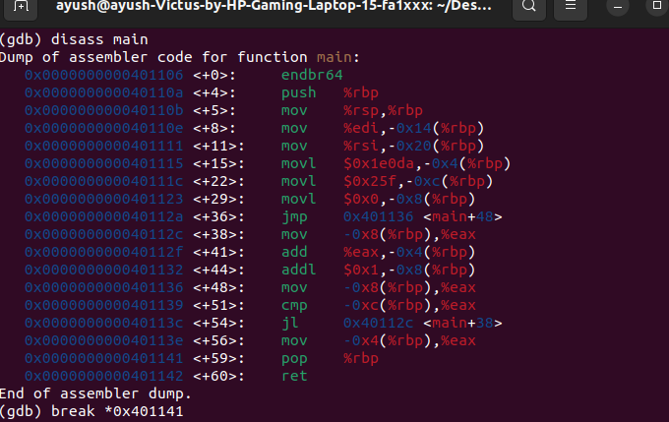
Now we make a breakpoint at the 56th line and then run the program
when the execution stops at breakpoint we look for the value in eax register using info registers command
We can clearly see that our flag is 307019.
4.) again in this challenge a ELF executable file is provided . Now when we used gdb to get information about functions and then we disassemble the main function to get
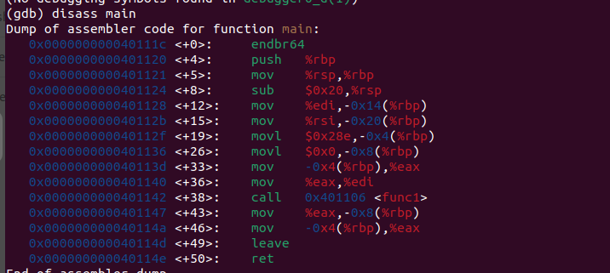
Now we can add two breakpoints one at 0x401142 and another one at 0x401147 to know the value stored in eax register before calling and after calling func1 respectively
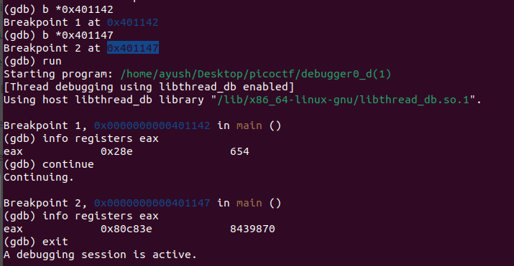
Now we can see the value in eax register before calling of functions (654) and after calling function (8439870) we can simply divide to get 12905 as our flag.
3.) again in this challenge a ELF executable file is provided . Now when we used gdb to get information about functions and then we disassemble the main function to get
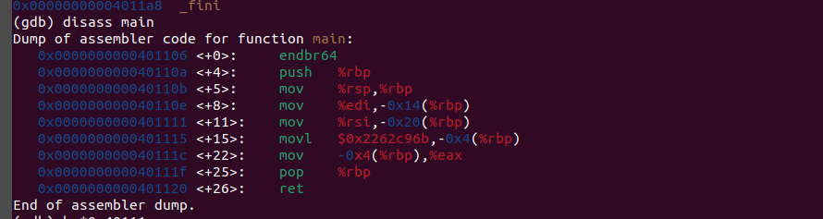
as we can see that the hexadecimal number is loaded in memory at 15th line so we set a breakpoint and then run the program
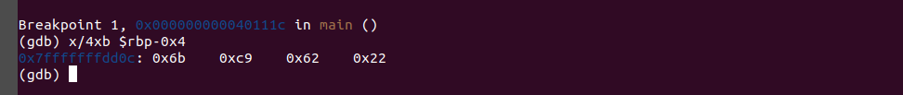
now we run the x/4xb command to get the required bytes

Reversing challenges :
1.) After downloading and extracting the zip file we get a ELF executable named keyg3nme after opening the executable in ghidra we get our main function
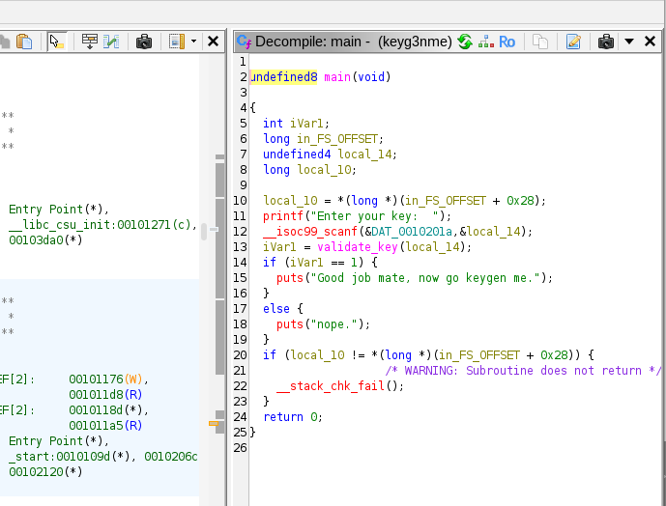

Now we can see that user input is taken and is sent to a function validate_key , if the function returns 1 then we are done !
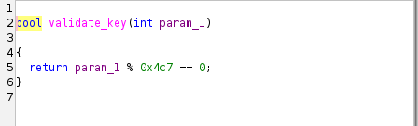

This is the validate_key function we can see that this function just check input modulo 1223 so we can input any multiple of 1223 .

2.) After downloading and extracting the zip file we get another executable rev03 opening it with ghidra we get :
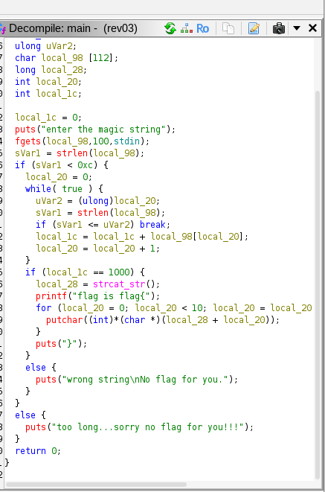

So we can see that a string of maximum length 112 is taken as input
and the length is stored in another variable called sVar1 , the length of string should be strictly smaller than 12 (0xc) now we can see that we are simply adding the ascii values of all charecters and it should sum out to 1000 , but the problem with this was that after pressing enter the system also took a \n charecter its ascii value is 10 and hence the sum should be 990 we can use the string
“cccccccccc”
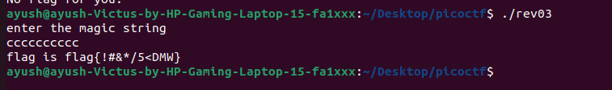
3.)

